|  |
| --- |
| **CAFÉ BILLING SYSTEM** |
| *Red Caffino CAFE* |
| The red caffino café offers a comfortable environment for everyone. Come and enjoy our selection of fine products. Our mission is to serve the downtown business community by providing the highest quality of products that meets the need of customer who are in hurry as well as those who want a place to relax and refresh by enjoying our delicious products. |
|  |
|  |
| ~ We Serve as good as we can ~ |
| **6/27/2022** |
|  |





**PROJECT TITLE:**

**CAFÉ BILLING SYSTEM**

**Submitted by:**

* **ABDULLAH NAEEM (Fall-21-BSCS-043)**
* **MUHAMMAD SOBAN (Fall-21-BSCS-046)**
* **ABDUL MALIK (Fall-21-BSCS-399)**

**Submitted to:**

**Prof .SAHAR MOIN**

**Submission date:**

**27/06/2022**

**Project duration:**

**2 Weeks**

**CONTENTS**

**TOPIC PAGE NO.**

1. Introduction 4
2. Problem Statement 4
3. Objectives 4
4. Analysis of Present System 4
5. Problems of Exisitng System 4
6. Characteristic of Proposed System 5
7. Future Scope 5
8. Technologies and Tools we used 5
9. Hardware 5
10. Program Output 6

* Display Menu
* Entry of Items and their Quantity
* Calculation an Display of Bill

1. Code 8

**OOP FUNCTIONS**

* **CLASSES**
* **OBJECTS**
* **CONSTRUCTORS**
* **INHERITANCE**

**CAFÉ BILLING SYSTEM**

1. **INTRODUCTION**

We proposed a “**Cafe Billing System”,** it is a program that automate the process of billing .It assists the process of entry of items and calculating the total bill for customer. The program can provide the fast service to the customers and hence improve the performance of our café. Hence maximizing the performance of our café and enable us to provide faster service to our customers.

1. **PROBLEM STATEMENT**

In our current situation with existing system, we face different problems like misunderstandings and miscalculations regarding billing.

We also get reviews of our customers regarding our billing system and as every businessman know that “**Seriously bad reviews will hurt business”.** So, to revoke and overcome these problems we need this system.

1. **OBJECTIVES**

This project will serve the following objectives:

1. Add and maintain description of new products.
2. Minimize the mess and crowd.
3. Provide convenient solution to billing problems.
4. Make an easy to use environment for user and customers.
5. Provide the faster service to customers.
6. Keeps the menu updated.
7. **ANALYSIS OF PRESENT SYSTEM**

Before we begin a new system it is important to study the system that will be improved or replaced (if there is one).We need to analyze how the system use hardware, software and the people resources efficiently .Thus we should document how the billing system perform activities of input, processing and output .

1. **PROBLEMS OF EXISTING SYSTEM**

The existing system has following flaws:

1. **Inability of modification of data:** The data medication is not possible in current system and cause problems.
2. **Not user friendly:** The existing system is not user friendly because the processing of data is manual thus slow.
3. **Maintenance:** Data is not maintained efficiently.
4. **Manual control:** Manual control is there and leads to a lot of chaos and errors.
5. **Lot of paperwork:** The existing system requires lot of paperwork and all records are kept manually on paper thus increase the cost wasted on paper**.**
6. **No support in decision- making**: Existing system does not support our requirements.

**6** .**CHARACTERISTICS OF PROPOSED SYSTEM**

The proposed system assists us in following ways:

1. **Easiness in modification of data:** The proposed system provides the facility to modify data efficiently.
2. **User friendly:** The system is user friendly because data entry and processing is fast and easier. Moreover the graphical user interface provides conveniency to user.
3. **No or very few paperwork:** The proposed system is completely computerized hence very little paperwork is required and all the processing is done electronically.
4. **Computer operator control:** Computer operator control will be there so it eliminates the chances of errors and work is done speedily and in time.
5. **Improves efficiency**: Bills are generated easily and efficiently.

**7 .FUTURE SCOPE**

1. This project will help the store keeper in fast billing.
2. Easy to maintain in future prospect.
3. This project enables the management team to keep their system updated.
4. Enable a store, café or shop to deal with their customers in a better way.

**8.TECHNOLOGIES AND TOOLS WE USED**

1. Development Tool: **DEV C++, VS CODE.**
2. Language used: **C++ OOP.**
3. Presentation Tool**: MS POWER POINT**
4. Documentation Tool: **MS Office Word**
5. Other

**9. HARDWARE**

* **CPU Configuration**

**-** Pentium IV or above

- RAM 1GB DDR2

* **Monitor**

-17” colour

* **Operating System**

**-**Windows XP with service pack 2

**10 .PROGRAM OUTPUT**

* **Display Menu:**

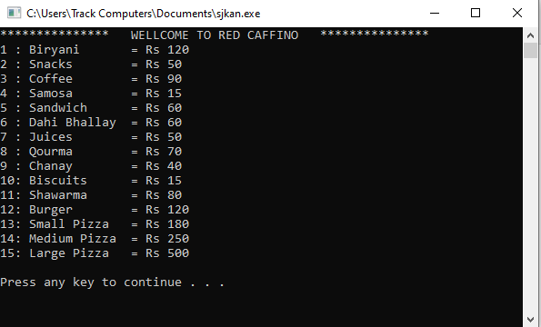

* **Entry of items and their quantity:**

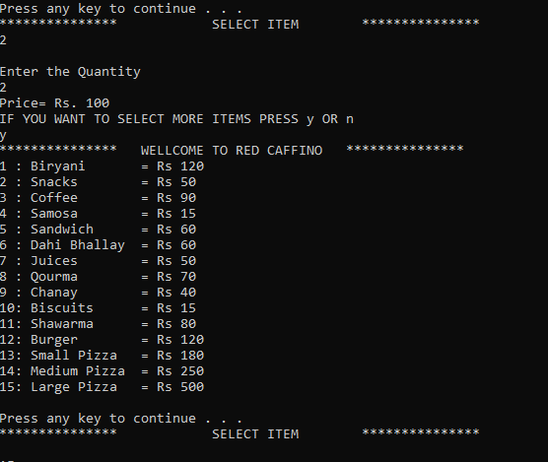

* **Calculation and display of Bill:**

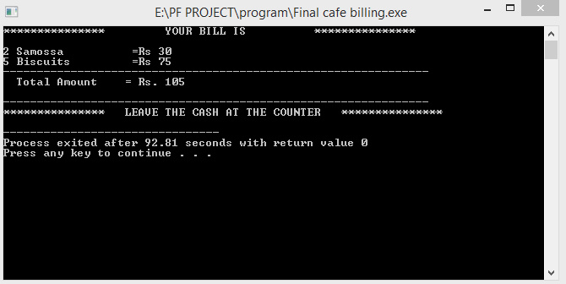

**11.CODE**

#include <iostream>

using namespace std;

class prices

{

protected:

int bir, sna, cof, sam, sand, dah, jui, qor, chan, bis, shw, burg, spiz, lpiz, mpiz;

public:

prices()

{

bir = 120, sna = 50, cof = 90, sam = 15, sand = 60, dah = 60, jui = 50, qor = 70, chan = 40, bis = 15, shw = 80, burg = 120, spiz = 180, lpiz = 500, mpiz = 250;

}

void display1()

{

cout << "** WELLCOME TO RED CAFFINO ** " << endl;

cout << "1 : Biryani = Rs " << bir << endl;

cout << "2 : Snacks = Rs " << sna << endl;

cout << "3 : Coffee = Rs " << cof << endl;

cout << "4 : Samosa = Rs " << sam << endl;

cout << "5 : Sandwich = Rs " << sand << endl;

cout << "6 : Dahi Bhallay = Rs " << dah << endl;

cout << "7 : Juices = Rs " << jui << endl;

cout << "8 : Qourma = Rs " << qor << endl;

cout << "9 : Chanay = Rs " << chan << endl;

cout << "10: Biscuits = Rs " << bis << endl;

cout << "11: Shawarma = Rs " << shw << endl;

cout << "12: Burger = Rs " << burg << endl;

cout << "13: Small Pizza = Rs " << spiz << endl;

cout << "14: Medium Pizza = Rs " << mpiz << endl;

cout << "15: Large Pizza = Rs " << lpiz << endl;

cout << endl;

system("pause");

}

};

class gettingopption : public prices

{

protected:

int option;

int T_Bill = 0;

int a, b, c, d, e, f, g, h, i, j, k, l, m, n, o;

int price1 = 0, price2 = 0, price3 = 0, price4 = 0, price5 = 0, price6 = 0, price7 = 0, price8 = 0, price9 = 0, price10 = 0, price11 = 0, price12 = 0, price13 = 0, price14 = 0, price15 = 0;

public:

void getoption()

{

cout << "** SELECT ITEM ** " << endl;

cin >> option;

cout << endl;

switch (option)

{

case 1:

cout << "Enter the Quantity \n";

cin >> a;

cout << "Price= Rs. " << a * bir << endl;

price1 = a * bir;

T_Bill += price1;

break;

case 2:

cout << "Enter the Quantity \n";

cin >> b;

cout << "Price= Rs. " << b * sna << endl;

price2 = b * sna;

T_Bill += price2;

break;

case 3:

cout << "Enter the Quantity \n";

cin >> c;

cout << "Price= Rs. " << c * cof << endl;

price3 = c * cof;

T_Bill += price3;

break;

case 4:

cout << "Enter the Quantity \n";

cin >> d;

cout << "Price= Rs. " << d * sam << endl;

price4 = d * sam;

T_Bill += price4;

break;

case 5:

cout << "Enter the Quantity \n ";

cin >> e;

cout << "Price= Rs. " << e * sand << endl;

price5 = e * sand;

T_Bill += price5;

break;

case 6:

cout << "Enter the Quantity \n ";

cin >> f;

cout << "Price= Rs. " << f * dah << endl;

price6 = f * dah;

T_Bill += price6;

break;

case 7:

cout << "Enter the Quantity \n ";

cin >> g;

cout << "Price= Rs. " << g * jui << endl;

price7 = g * jui;

T_Bill += price7;

break;

case 8:

cout << "Enter the Quantity \n ";

cin >> h;

cout << "Price= Rs. " << h * qor << endl;

price8 = h * qor;

T_Bill += price8;

break;

case 9:

cout << "Enter the Quantity \n ";

cin >> i;

cout << "Price= Rs. " << i * chan << endl;

price9 = i * chan;

T_Bill += price9;

break;

case 10:

cout << "Enter the Quantity \n ";

cin >> j;

cout << "Price= Rs. " << j * bis << endl;

price10 = j * bis;

T_Bill += price10;

break;

case 11:

cout << "Enter the Quantity \n ";

cin >> k;

cout << "Price= Rs. " << k * shw << endl;

price11 = k * shw;

T_Bill += price11;

break;

case 12:

cout << "Enter the Quantity \n ";

cin >> l;

cout << "Price= Rs. " << l * burg << endl;

price12 = l * burg;

T_Bill += price12;

break;

case 13:

cout << "Enter the Quantity \n ";

cin >> m;

cout << "Price= Rs. " << m * spiz << endl;

price13 = m * spiz;

T_Bill += price13;

break;

case 14:

cout << "Enter the Quantity \n ";

cin >> n;

cout << "Price= Rs. " << n * mpiz << endl;

price14 = n * mpiz;

T_Bill += price14;

break;

case 15:

cout << "Enter the Quantity \n ";

cin >> o;

cout << "Price= Rs. " << o * lpiz;

price15 = o * lpiz;

T_Bill += price15;

break;

}

}

void showbill()

{

cout << "** YOUR BILL IS **\n";

cout << endl;

if (price1 > 1)

{

cout << a << " Baryani =Rs " << price1 << endl;

}

if (price2 > 1)

{

cout << b << " Snacks =Rs " << price2 << endl;

}

if (price3 > 1)

{

cout << c << " Coffee =Rs " << price3 << endl;

}

if (price4 > 1)

{

cout << d << " Samossa =Rs " << price4 << endl;

}

if (price5 > 1)

{

cout << e << " Sanwitch =Rs " << price5 << endl;

}

if (price6 > 1)

{

cout << f << " Dahi Bhallay =Rs " << price6 << endl;

}

if (price7 > 1)

{

cout << g << " Juice =Rs " << price7 << endl;

}

if (price8 > 1)

{

cout << h << " Qourma =Rs " << price8 << endl;

}

if (price9 > 1)

{

cout << i << " Chanay =Rs " << price9 << endl;

}

if (price10 > 1)

{

cout << j << " Biscuits =Rs " << price10 << endl;

}

if (price11 > 1)

{

cout << k << " Shawarma =Rs " << price11 << endl;

}

if (price12 > 1)

{

cout << l << " Burger =Rs " << price12 << endl;

}

if (price13 > 1)

{

cout << m << " Small Pizza =Rs " << price13 << endl;

}

if (price14 > 1)

{

cout << n << " Medium Pizza =Rs " << price14 << endl;

}

if (price15 > 1)

{

cout << o << " Large Pizza =Rs " << price15 << endl;

}

cout << "---------------------------------------------------------------";

cout << endl;

cout << " Total Amount = Rs" << price1 + price2 + price3 + price4 + price5 + price6 + price7 + price8 + price9 + price10 + price11 + price12 + price13 + price14 + price15 << endl;

cout

<< endl;

cout << "---------------------------------------------------------------";

cout << endl;

cout << "** LEAVE THE CASH AT THE COUNTER ** " << endl;

cout << "** THANK YOU ** " << endl;

}

};

int main()

{

prices show;

gettingopption g;

label:

show.display1();

g.getoption();

char yes;

cout << "IF YOU WANT TO SELECT MORE ITEMS PRESS y OR n " << endl;

cin >> yes;

if (yes == 'y')

{

goto label;

}

else

{

system("cls");

g.showbill();

}

return 0;

}

